Approach for enrollment status module

# Background

Enrolment packets created by the enrolment clients will be periodically uploaded to the server for processing. The packets will be further processed and in each step status will be updated in enrollment status table.

The target users are

* Client application, which will use search API to get current status of packets.
* Server application which will process the packets
* Administrator of the platform who may need to verify the packets

The key requirements are

* Get enrollment status based on id.
* Get the enrollment based on status.
* Update enrollment status.
* Add enrollment status.
* Provide rest API to get the enrollment statuses for list of enrollment ids.

The key non-functional requirements are

* Performance: Should fetch information from DB in less time for millions of records. Should be able to support processing multiple status requests per second.

# Solution

The key solution considerations are -

* Create “enrollment” and “enrl_transactions” table by executing attached DB scripts.
* Enrollment and Transaction
* Create Enrollment and Transaction entity and create dao layer for below crud operations:
  + Add new enrollment status.
  + Add Transaction details with transaction type code and status code (TRANSACTION_STARTED, TRANSACTION_SUCCESSFUL, and TRANSACTION_FAILED).
  + Get enrollment status by ID.
  + Update enrollment status.
  + Get enrollment status by status code.
  + Find enrollment status by time threshold on creation date time.
* Provide rest API to search enrollment status based on list of enrollment ids.
* Handle exceptions in using custom Exception handler and send correct response to client.
* Audit the entire transaction.

**DB scripts:**

 

Class Diagram:

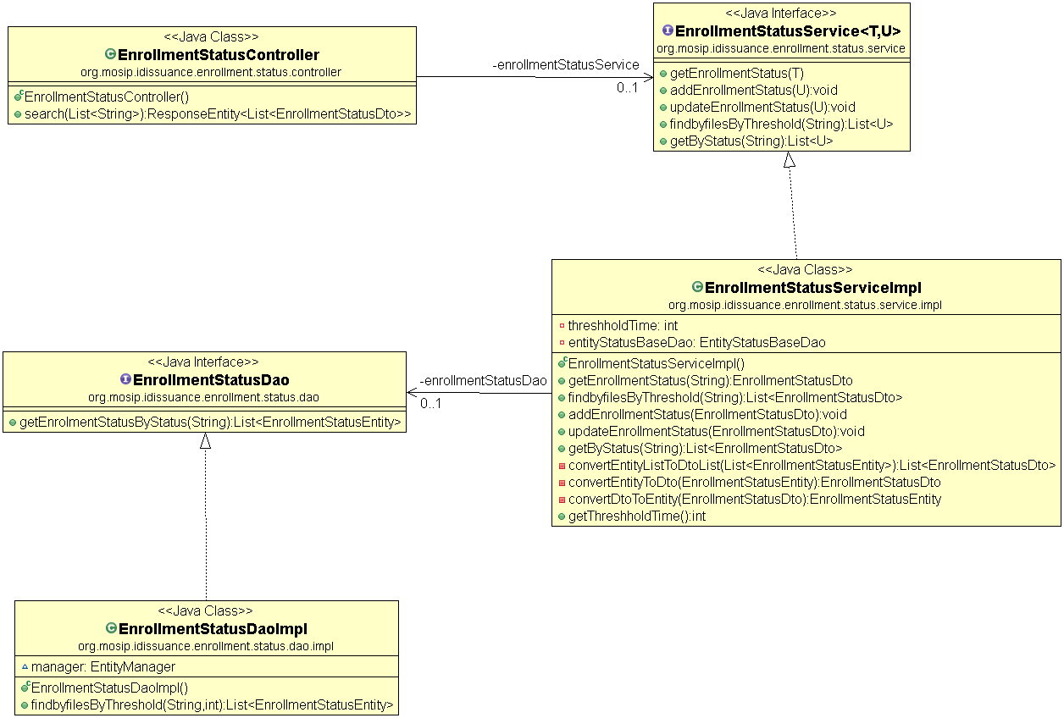

Sequence Diagram:

